**Other Wolfe Family Members**

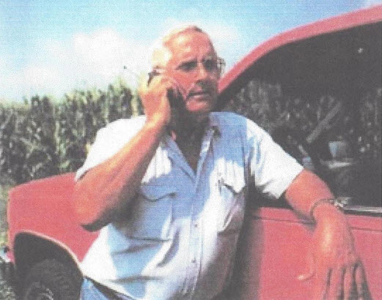

Edward “Ned” Kay Wolfe, son of Ursula & Harrison Wolfe, grandson of Edward O. Wolfe,

second cousin of Lois, Philip, Mary Jo, Nelson, and John Wolfe – about 1990

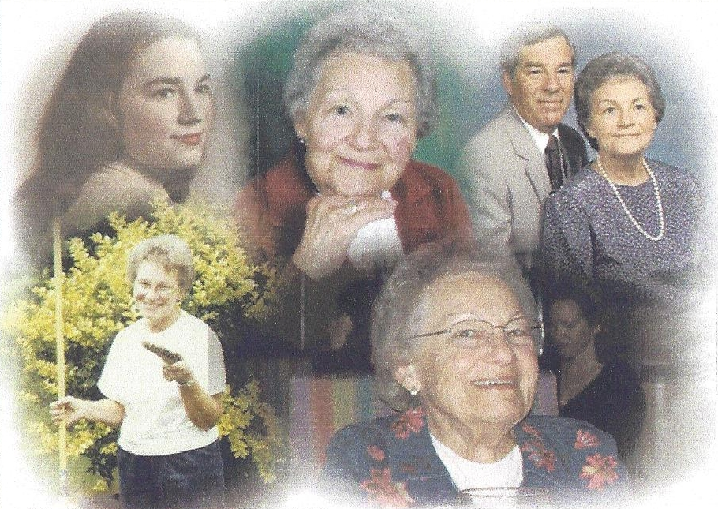

Patricia “Patty” A. Wolfe Pontius, Daughter of Ursula & Harrison Wolfe

2nd Cousin of Lois, Philip, Mary Jo, Nelson, and John Wolfe – (1928-2013)